Strengthening Election Management in Bangladesh (SEMB)

YEARLY PROGRESS REPORT
1 January 2012 -31 December 2012

United Nations Development Programme (UNDP) Bangladesh

Implementing Partner
Bangladesh Election Commission
No. and title of the project: No. 00078498; Strengthening Election Management in Bangladesh

Executing Agency Bangladesh Election Commission

Project Period April 2011 – March 2016

Reporting period 1 January 2012 – 31 December 2012

Reporting Agency UNDP Bangladesh

Project Goal To enhance and further consolidate the institutional and professional capacities of the BEC, its Secretariat and local offices to deliver its mandated functions of conducting fair, credible and transparent elections and further consolidating itself as a permanent, professional, credible and independent institution of governance.

Management Arrangement National Execution (NEX)

Contact Person Md. Salim Khan, Project Coordinator (a.i.)
(Ph:8181672, e-mail: salim.khan@sembec.org.bd)

TABLE OF CONTENTS

Page no
Executive Summary 6

Chapter 1: Introduction 9

Chapter 2: Project Background 11
2.1 Purpose
2.2 Key Objectives

Chapter 3: Key Achievements and Outputs 12
3.1 Training 12
3.2 Decentralisation and Institutional Growth 14
3.3 Communication and Partnership 16
3.4 ICT 17
3.5 Management of Voter List 19
3.6 Preparation for next parliamentary election 2013/4 25
3.7 Indicator Framework 26

Chapter 4: SEMB Management and Operations 29
Management Structure 29
Staffing 29
Monitoring and Evaluation 30
Operational Challenges and Changes to Project 30
Partnerships 31
Visibility 31

Chapter 5: Lessons Learned and Way forward 34

Chapter 6: Financial Report 36

Annex 37
Table - List of Major Trainings 37
Table – Key Workshops and Meetings 39
Table - Consultation Schedule of Election Commission 45
Table – List of Documents and Publications Produced 46
Table - Project Recruitment Status 47

List of Acronyms
AWP Annual Work Plan
BEC Bangladesh Election Commission
BVRS Bangladesh Voter Registration System
CEC Chief Election Commissioner
CSSED Construction of Server Stations for Electoral Database
CTG Caretaker Government
DCS Direct Country Office Support
DEC Deputy Election Commissioner
DEX Direct Execution
DFID Department for International Development
ERD Economic Relations Division
ETI Electoral Training Institute
EU European Union
ICT Information Communication Technology
IDEA Identification System for Enhancing Access to Services
GoB Government of Bangladesh
LVRS Local Voter Registration System
NEX National Execution
NNEB Network for National Election Management Bodies
NPD National Project Director
PERP Preparation of Election Rolls with Photograph
PSC Project Steering Committee
PIC Project Implementation Committee
RPO Representation of People’s Order
QWP Quarterly Work Plan
SBS Step by Step Guide
SEMB Strengthening Electoral Management in Bangladesh
SEPB Support to the Electoral Process in Bangladesh
TBB Translucent Ballot Boxes
UP Union Parishad
UNDP United Nations Development Programme
USAID United States Agency for International Development

EXECUTIVE SUMMARY

The project “Strengthening Election Management in Bangladesh (SEMB),” aims to enhance national electoral processes and consolidate as well as further improve the institutional and professional capacity of the Election Commission Bangladesh (ECB). This report covers the project’s achievements from 1 January 2012 to 31 December 2012. Initiatives undertaken over this period to take necessary preparations to organize and manage upcoming 10th Parliamentary Election and implementation of capacity development activities to promote more professional electoral administration once the project’s momentum was established; and extended in 2012 to include strategic positioning and planning for the next parliamentary election expected by January 2014.

The main project results are below.

- Training
SEMB enhanced the ability of the Commission’s Electoral Training Institute (ETI) to systematically plan and more professionally implement trainings. The project ushered in organisational reforms to training approaches with the creation of the first Strategic Plan, providing a longer term vision to guide ETI’s organisational development. Heightened training skills and delivery techniques of 40 BEC trainers, including key staff of ETI, were achieved with the introduction of the professional development programme – BRIDGE. Consequently, 60 BEC staff increased their knowledge of essential electoral processes with the delivery of six specialised BRIDGE modules. The introduction of BRIDGE also initiated a sustainable training development process premised on creating a pool of local BRIDGE facilitators, internationally recognised and capable of implementing trainings of highest standards, with three local officials successfully accredited.

The electoral assistance provided through SEMB, advanced the profile and reach of ETI and enabled the training department to modernize both its training methods and physical premises. Assistance through SEMB, ultimately served to advance the overall goal of mainstreaming professionalised training as the basis for creating a knowledge driven and more efficient Election Commission able to operate at the highest standards of election management.

- Decentralisation and Institutional Growth
SEMB enhanced the ability of the BEC to manage its institutional growth and processes through (i) raising awareness on BEC’s vision and plans at local levels; (ii) facilitating the development of more efficient organisational structures and procedures and; (iii)supporting BEC’s analysis of potential areas for innovation in election delivery to inform policy making.

The dissemination of BEC’s first Strategic Plan and Action Plan, coupled with stakeholder engagements, increased the awareness of 266 local election officials of BECs’ corporate vision and targets. With the completion of the organisational restructuring exercise, a new BEC organogram, with detailed departmental functions and job descriptions were produced, promoting more efficient institutional set-up. Enhanced capacity for future election administration was promoted through the collation of lessons gleaned through five post-election workshops involving 266 election officials. The findings have filtered into the on-going review of election processes and manuals. Research into potential areas of innovation in election management to inform BEC decision making and policy formulation was supported. In this regard, pilots of the electronic monitoring and security management system of Polling Stations were supported as well as pilots of electronic voting machines (EVM) in select sub-national level elections.

3. Communication and Partnership
SEMB project is committed to enhance BEC’s capacity for more competent communications management and to increase the organisation’s ability to engage with national and international electoral stakeholders. With the project’s support, BEC and civil society groups partnered to promote greater awareness and transparency in elections with the organization of candidate debates and dissemination of candidate information for local and city corporation elections. The first stakeholder consultation of the new Election Commissioners with political parties, civil society and media on a range of electoral management issues was facilitated by the project. This is intended to be a continuous engagement and future consultations are planned. Additionally, to further promote transparency of BEC activities, a quarterly Bangla newsletter was regularly produced and distributed to a range of electoral stakeholders. (date and list of political parties)
- Information Communication Technology (ICT)
With SEMB support, the BEC enhanced its ability to utilise ICT in election management. The launch of the development phase of a new election management system promoted greater transparency and efficiency in electronic systems for results management; candidate management as well as management of polling station and polling official databases. Four modules for this automated system were developed and will be further enhanced in the coming months and finalised ahead of the next parliamentary polls. Experiments with mobile technology utilising phone messaging systems to provide voters with information on their polling station location, unique serial number and to circulate information on voter registration proved highly successful and will be further developed. These technologies open up new frontiers and offer new possibilities for the BEC in modernising electoral processes which compliments advances previously achieved with the creation of a modern biometric voter list.

5. Management of Voter List
SEMB built on the past successes of the PERP project to provide continuous support for the maintenance of a credible voter list. Electoral assistance aimed to further institutionalise voter registration processes and consolidate gains achieved through past investments in human and material resources. In this regard, the implementation of the 2012 nation-wide voter registration update programme was supported, with specific assistance provided for training of BEC voter registration staff nationwide, delivered by ETI; procurement of necessary hardware and software for voter registration; plus technical and financial assistance to ensure the process remained technically and logistically sound. The nation-wide update process started in March 2012 and has progressed relatively smoothly and completed on 15 December 2012. By December 2012, the Commission registered 7.01 million new voters to the existing voter roll. Lessons learned workshops have followed each phase of the country wide registration process to continuously improve operations as the update process proceeds.

Pilots of voter registration (VR) were carried out in 2011, which successfully predicted the registration trends witnessed in 2012 and facilitated the finalisation of VR standard operating procedures, which were further enhanced from the 2008 polls. Additionally, a technical review of VR processes served to enhance VR operations and efficiency.

Decentralisation of Voter Registration remains a priority of the BEC and its implementation was advanced by the project, with the development of an implementation plan to guide the roll out of the local voter registration system to the upazillas. Furthermore SEMB promoted increased coordination and synergies in this area by establishing a Coordination Committee, comprised of all projects and departments that relate in some way to voter registration and functioning of decentralised electoral services.

6. Preparation for next parliamentary election 2013/4

The timely preparation and positioning of electoral assistance was prioritised during the reporting period and a Planning Mission was fielded in 25 August to 4 September 2012 that assessed the on-going technical preparations for the upcoming parliamentary election in 2013/4 and provided recommendations to the Election Commission to enhance the quality of their plans. Mission provided vital inputs to guide the development of the electoral assistance strategy of SEMB in 2013 as well as areas of focus for the Commissioners and Secretariat which duly considered potential risks and benefits. Support in this effort is reinforced by initiatives undertaken in the other 5 Outputs of the project.

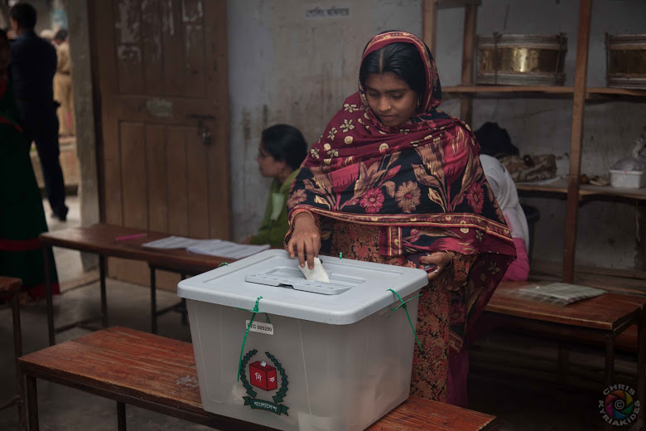
A woman votes in a 2012 Gazipur by-election

Chapter 1: INTRODUCTION

Bangladesh has a track record of holding elections and has held nine parliamentary polls since its independence in 1971. While the country has a history of elections and transfer of power, there have been instances when the democratic rule has been interrupted. However Bangladesh has been largely under democratic rule since the 1991 overthrow of the military regime. Parliamentary elections are held every five years for 300 single-member constituencies on a first-past-the post basis and local elections are held at Union Parishad, Pourashava (Municipal Councils), Upazila and City Corporations every five years. Public demand and turn-out in elections is generally high and averages about 75%, with the 2008 poll witnessing a record turn-out of 86.3%. Elections remain the main avenue for citizens to participate and have a voice in decision-making however the quality of engagement throughout the electoral process requires further improvement.

The Bangladesh Election Commission (BEC) is the constitutionally established body responsible for conducting elections. The body is headed by a Chief Election Commissioner and four Commissioners. Its operations are run by its Secretariat. Administration of elections requires over 500,000 local officials and poll workers and close to 500,000 security officials to administer successful elections. This makes election administration a major logistical and administrative task.

System wide reforms in 2007 to 2009, led by the Caretaker Government and BEC, overhauled the electoral landscape. The reforms improved the capacity of the BEC, overall national capacity for electoral administration and reinstated public confidence in the democratic process, following the 2007 collapse of the electoral process. The Election Commission Secretariat Act (ECS) was introduced in 2009 which separated the Commission from the Prime Minister’s Office and established the independence of the Commission. Amendments were made to the Representation of the People’s Order (RPO) which included mandatory political party registration plus requirements to revise campaign financing limits and candidate nomination procedures. Revisions to the Code of Conduct were introduced in an attempt to limit black money and muscle in elections.

Recent elections have been relatively transparent and free and fair. The 2008 parliamentary poll has been deemed to be one of the most successful by observers. The over 1000 local elections that followed have also been deemed to be credible. While successes exist, there is recognition that several challenges persists to the institutional strength and efficiency of the BEC. This reinforces the need for the organisation to further develop and consolidate existing skills and capabilities to conduct elections. Particularly, to build on the successful reforms and achievements witnessed in 2007 and 2008. The next parliamentary election can be declared anytime from October 2013 to January 2014 and consolidating past successes achieved in electoral reform for these elections will be paramount.

The political environment in Bangladesh poses significant challenges to the conduct of credible, democratic parliamentary elections. High levels of rivalry between the largest political parties and fierce political competition has hampered the development of democratic governance and serves as the biggest threat to creating an enabling environment for credible and peaceful elections. To facilitate free and fair elections, a non-party Caretaker Government (CTG) was introduced within the legal framework in the 1991 parliamentary elections and institutionalised in 1996. It was however later removed in 2011 through a constitutional amendment. This controversial removal of the CTG rests at the centre of an on-going political stalemate. Arriving at a negotiated settlement to this matter ahead of the election will be vital to the success of the upcoming parliamentary polls.
Lessons from the 2008 election suggest that buy-in and active participation of all the major stakeholders in the electoral process are essential for success. It also emphasizes the importance of ensuring technical robustness of election administration; ensuring high standards of election management and public confidence in the electoral processes. However a long term approach with electoral assistance throughout the entire electoral cycle will be key for consolidating achievements and enhancing further advancements in election management and administration.

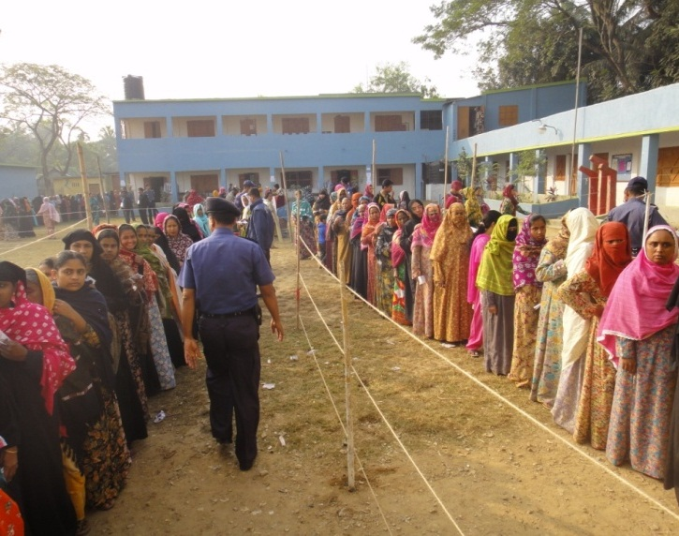
Chapter 2: PROJECT BACKGROUND
Women wait in line to cast their vote in a City Corporation election

2.1 Purpose
Strengthening Election Management in Bangladesh (SEMB) project is a five-year technical assistance project designed to enhance and further consolidate the institutional and professional capacities of the Bangladesh Election Commission (BEC), its Secretariat and local offices to deliver its mandated functions of conducting credible and transparent elections. SEMB is Nationally Executed (NEX) and funded by four development partners, namely European Union (EU), United States Agency for International Development (USAID), UK Department for International Development (DFID) and United Nations Development Programme (UNDP), with in kind contribution committed by the Government of Bangladesh.

The project builds on past electoral assistance provided by UNDP for over 10 years and adopts a long term approach to election support that is premised on the view that comprehensive and continuous assistance is the most effective approach to institutionalize reforms and sustainably achieve capacity building of the BEC and its affiliates at regional and sub-regional levels.

2.2 Key Objectives and Outputs
To support the achievement of the outcome results the project is supported by six outputs:
- Professionalize and strengthen the training capacity of the BEC;
- Strengthen BEC capacity to efficiently manage decentralization and institutional growth;
- Enhance the communication and outreach mechanism of the BEC;
- Strengthen the ICT wing of BEC;
- Enhance the capacity to prepare and disseminate a credible and accurate photo voter registration;
- Support activities to the upcoming Parliamentary election;

Below structure gives an overview of the project outcomes and outputs at the activity result level;
PROJECT OUTCOME: By 2016, the Bangladesh Election Commission (BEC) organizes and supervises credible elections at all levels throughout the election cycle

OUTPUT 6:
BEC's activities in run up to the 2014 parliamentary elections are supported.
OUTPUT 5:
By 2016, the BEC is able to manage a credible and accurate voter register.
OUTPUT 4:
By 2016, the BEC is able to use Information Communication Technologies in election management
OUTPUT 3:
By 2016, the BEC is able to effectively communicate through the media & establish/ build partnerships
OUTPUT 2:
By 2016, the BEC is able to operate effectively and in a decentralized manner
OUTPUT 1:
By 2016, the training institute of BEC is able to plan, implement and evaluate training for BEC staff

Chapter 3: KEY ACHIEVEMENTS AND OUTPUTS

Project Official Launch - Inception Meeting
The inception meeting of the SEMB project was held on 8 August 2011 in Dhaka. The meeting presented the scope of the project, its design and intended outcomes to key stakeholders and allowed for constructive engagements on project aims which were subsequently used to guide the project’s implementation.

  - TRAINING

Scope of interventions
Training initiatives under SEMB aim to reform the BEC’s training department - ETI, leading to more professionalised approaches and delivery of training within the Election Commission. It seeks to raise profile, recognition and organisational capacity of ETI to more effectively support and drive the training needs of the Commission.

Planned Activities and Results

Development of ETI vision and plan

Strategic Plan for the Electoral Training Institute (ETI)
The ETI Strategic Plan was developed through a three day interactive workshop held from 3-5 June 2012, and involved officers of the ETI as well as key personnel from the BEC Secretariat. The ETI Strategic Plan outlines how the work of ETI will specifically contribute to meeting of the Strategic Goals of the Bangladesh Electoral Commission. It is therefore a subordinate plan and supports to realisation of vision and goals of the overall Electoral Commission Strategic Plan and Action Plan. The draft ETI Strategic Plan is currently awaiting final approval by the Commission.

Capacity Assessment of ETI
Capacity Assessment of ETI was conducted from April to May 2012. The assessment focused on the ability of ETI to be the driver of the BEC’s capacity development initiatives, as envisioned in the Commission’s Strategic visions. The assessment was a structured process, employing recognised capacity assessment tools and the capacity assessment report produced identified the strengths, capacity gaps and recommendations for improvements.

The ETI currently has 13 Officers and 40 staff. The assessment concluded that ETI is a very cohesive unit and Officers have the capability to be the focus and drivers of the BEC capacity development strategy. However a few key areas need to be addressed to more successfully facilitate this. These include (i) ETI will need to develop a comprehensive vision and strategy; (ii) ETI requires greater exposure and training in the most recent adult training methodologies such as BRIDGE; (iii) ETI will need to address the lack of gender balance in their roster and (iv) ETI will need to develop a robust monitoring and evaluation framework to ensure their training is demonstrably effective, has value and is continually improving. Support for addressing these identified areas is/will be supported by SEMB.

Development of Draft Training Plan
ETI provides training in two broad areas, staff capacity development aimed at strengthening officers’ administrative capabilities in areas such as finance, management and computer training s and specific electoral training for BEC officials and various stakeholder groups. Technical assistance was provided to produce a draft training plan incorporating all of these areas. In this context, the ETI also started an evaluation process of pre and post testing in an effort to gauge the effectiveness of their training. ETI will build on this in 2013, with SEMB support, to develop a full and comprehensive monitoring and evaluation framework.

Strengthen ETI training skills and delivery

Introduction of BRIDGE
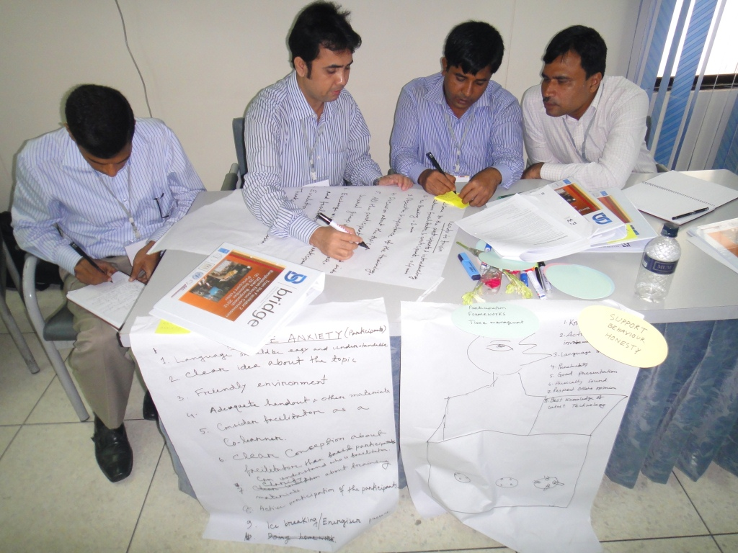
In 2011 the BEC made a decision to introduce the Building, Resources in Democracy, Governance and Elections (BRIDGE) program to strengthen staff capacity, with the assistance from SEMB. It envisaged that not only will ETI be a recipient of such a program, they will be the primary mechanism for the delivery and BRIDGE will be a tool utilised to facilitate BEC and ETI’s fulfilling its Mission Statement and realising its vision of more professionalised and systematic training within the organisation. Furthermore, BRIDGE workshops would target BEC staff but will also extend to other stakeholders and serve as a means for increasing stakeholder engagement.

BRIDGE is a professional development programme with a particular focus on electoral and broader governance processes. Modules are tailored to the particular needs of the country and the programme includes accreditation of specially trained and accredited facilitators that are internationally recognised as BRIDGE facilitators. Two ‘Train the Facilitator’ (TtF) courses were conducted under SEMB in which a total of 40 BEC officials became semi accredited, and three fully accredited. This has advanced the goal of creating a pool of capable and well trained facilitators able to plan and deliver effective trainings. The accreditation process of facilitators will be continuously supported by SEMB.
Participants in BRIDGE Training

By end of December 2012, a series of other BRIDGE activities were implemented including six other BRIDGE specialised trainings on Introduction to Electoral Administration – 1 & 2, Strategic Planning Workshop for ETI, Legal Framework, Gender and Elections, Training Strategy and Capacity Building Workshop supported by SEMB (see Annex on trainings).

English Language training with the British Council
A General English Language Training course was organized for officials of commission secretariat, ETI, NID wing, regional and field level offices. The objective of the course is to build and strengthen further capacity of BEC officials for official purpose, build capacity to participate in international level training workshop and to maintain communication with international counterpart.
SEMB supported English language training of 54 BEC staff at the British Council. Of this total, only 12% of participants were women. This assistance falls within ambit of establishing a more professional and well trained organization, better equipped to engage with all stakeholders.

Refurbishment of New and More Modern ETI Office
The Electoral Training Institute (ETI) was relocated to more suitable offices and was equipped with new furnishings and training equipment such as whiteboards, cameras, sound system and projectors as SEMB worked to create a more conducive learning environment. Additionally, SEMB supported the coverage of 50% of the rent for ETI office spaces.

3.2 DECENTRALISATION AND INSTITUTIONAL GROWTH
Scope of interventions
Through this output, SEMB worked to support the BEC to manage its institutional growth and enhance its operational processes. With a focus on enhancing organisational development, SEMB promoted more efficient operations through (i) raising awareness on BEC’s vision and plans at local levels; (ii) facilitating the development of more efficient organisational structures and procedures and; (iii) supporting BEC’s analysis of potential areas for innovation in election management to inform future policy making potentially leading to the BEC’s adoption of more sustainable initiatives.

Planned Activities and Results

Dissemination and Monitoring of BEC’s Strategic Plan and Action Plan

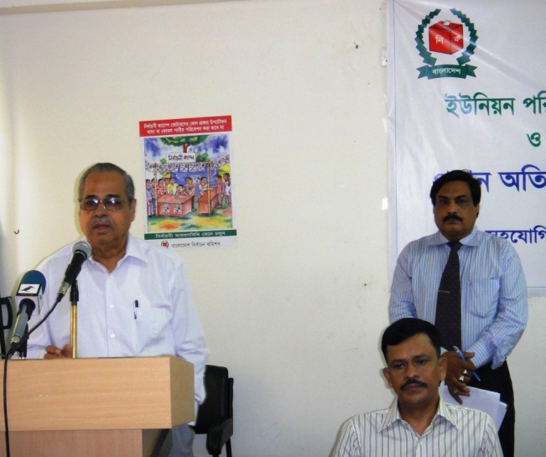
The BEC developed a five-year strategic plan (2011-2016) and a two year action plan (2011-2013), in 2010, with support from the UNDP Preparatory Assistance to Electoral Reform. Throughout the reporting period, SEMB facilitated BEC’s dissemination of these plans to local election officials and over 266 election officials participated in five workshops. The engagements focused on discussions on the BEC vision, mission and priorities as stated in the strategic plans and the relationship and role of local election offices in achieving core goals. Electoral stakeholders from the range of Government agencies with which the BEC works, civil society and media also participated in sessions of these workshops, which resulted in the sensitization of not only electoral officials but also key stakeholders on the vision of the BEC.

The dissemination and stakeholder discussions proved to be successful in reviewing the current implementation status of the BEC strategic plans and in providing feedback to strengthen operational procedures, inform areas for future training and notably to collect feedback to strengthen the current and future operations of local offices. SEMB project has documented the recommendations emanating from consultations for future utilization and BEC planning.
Mr. Kazi Rakib Uddin Ahmed, CEC, speaking at a Strategic Plan Dissemination Meeting

The Chief Election Commissioner (CEC) led and participated in the dissemination and stakeholder consultations, which meant that the BEC plans were communicated and discussed with the highest election official which proved successful to foster local level buy-in.

Post-Election Lessons Learned Workshops

Union Parishad Elections
Union Parishad (UP) elections were held in two phases in 2011. The first phase was from 29 March 2011 to 3 April 2011 and second phase, from 5 May 2011 to 5 July 2011. A total of 4300 UP elections were held and 204 did not take place due to a range of complexities, most being of a legal nature. SEMB supported five lessons learned workshops in 2012 to assess the effectiveness of UP electoral administration and collect lessons to improve electoral procedures for future elections (see Annex list of workshops). The workshops covered five of 10 electoral regions or 50% of the total electoral area for the UP elections. Workshops included election officials and stakeholders, such as security and government personnel, that were directly involved in the administration or security of elections. Workshops also involved a well-developed questionnaire coupled with an interactive session with the Commissioners and senior BEC Secretariat officials.

Findings from workshop suggest that the UP elections were administered in a professional and credible manner. Election officials were generally knowledgeable of election rules and feedback reinforced the usefulness of existing election laws and procedures. It also revealed that while solid electoral rules existed, there is a need for more stringent application of these rules to ensure greater efficiency. The importance of increased training to election officials and public was underscored including training and sensitization on the relevant laws and procedures before the election. The need to improve the coordination, efficiency and general capacity to maintain law and order was raised as well as the utilisation of automated mechanisms for filing of candidates, results management to increase speed and efficiency of these electoral processes. Several other recommendations have been documented and are under consideration by the BEC.

International Visits for Knowledge Exchange and Creation

Election Observation – Myanmar:- Mr Mizanur Rahman, Assistant Secretary of BEC visited Myanmar to observe their national election on 1 April 2012. A report was produced and shared with relevant officials within BEC.

Professional Certificate in Electoral Processes: Dr. Muhammed Sadique, Secretary, Election Commission Secretariat and Mr. Md. Abul Kasem, Deputy Secretary, ECS Participated in a training course in London, UK from 26th - 30th November 2012. This is a specialist training course leading to a Level 5 Chartered Management Institute (CMI) Certificate in Management and Leadership.

Knowledge Sharing between Australian Election Commission (AEC) and Election Commission Bangladesh (ECB): A five member team headed by Mr. Mohammad Abu Hafiz, honourable Election Commissioner, Mr. Md. Sirazul Islam, Additional Secretary and NPD, SEMB, Mr. Md. Nuruzzaman Talukder, District Election Officer, Rangpur, Ms. Mahfuza Akter, Upazila Election Officer and Ms. Rae Ann Peart, Program Specialist, Governance Cluster, UNDP had an exchange visit in Canberra, Australia from 14 October – 19 October 2012. The AEC and ECB have a history of knowledge sharing and gleaning of international best practices to improve election management and administration. The two organizations intend to further develop a healthy interaction that would strengthen election management and administration in Bangladesh.
3.3 COMMUNICATIONS AND PARTNERSHIP
Scope of interventions
SEMB initiatives promoted increased transparency of the BEC and its ability to engage and partner with national electoral stakeholders. It also served to raise the level of voter awareness on electoral procedures and processes.

Planned Activities and Results

BEC Stakeholder Consultation
The first stakeholder consultation of the Election Commissioners with civil society on a range of electoral management issues was facilitated by the project. Consultation focused on getting feedback of on-going and impending electoral processes such as the delimitation of boundaries and voter registration. This is intended to be a continuous engagement and the BEC had a series of consultations with Political parties, Civil Societys, Media, editors, NGOs and voters (see Annex of consultation schedule of Election Commission).

Consultation of the previous Commission with political parties was also facilitated by the project. A publication on recommended reforms to electoral laws emanating from the Political Party dialogues has been printed, with SEMB support.

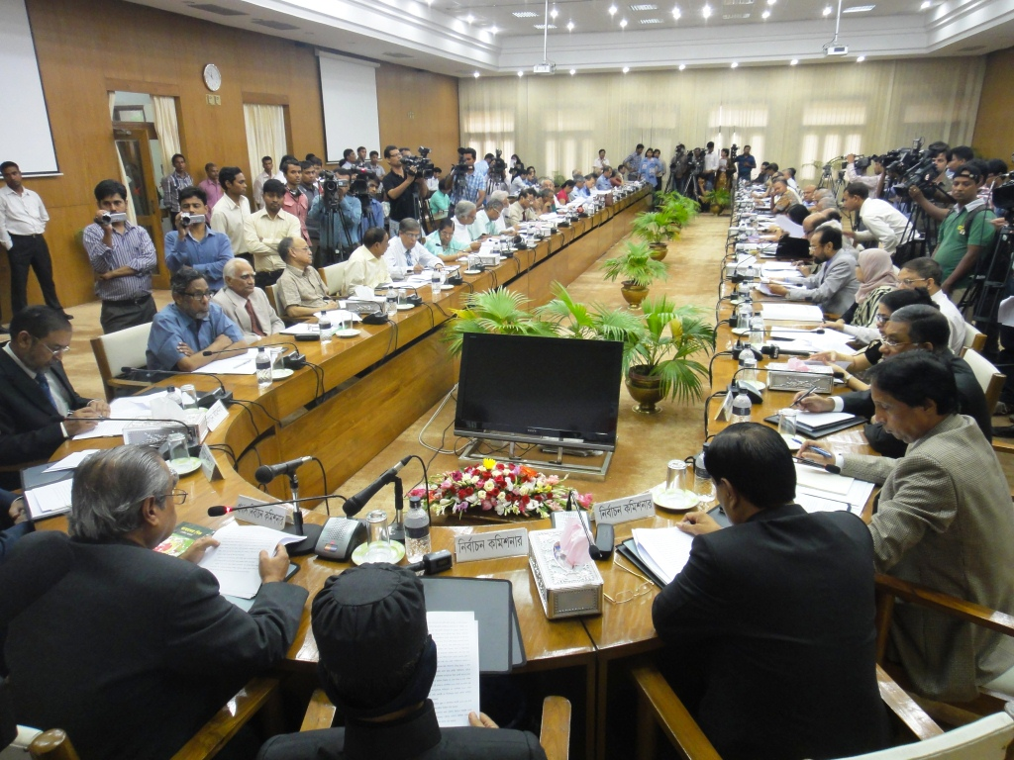
BEC Consultation with Civil Society

Candidate Debates and Dissemination of Candidate Information
Meetings were organized with mayoral and councilor candidates for the Comilla City Corporation Elections and Narsingdi by-elections in order to generate greater awareness among voters on the manifesto, commitments and activities of the candidates and to help voters to make more informed choices. These meetings were organized by SHUJAN, a civil society group, which was selected to design and organize the activities at the community level. Materials such as leaflets, posters and comparative statements of the candidates were printed and distributed to voters during the campaign period.

Voter Awareness
Activities to create increased awareness of voters and polling officials on the use of electronic voting machines (EVMs) for the Narayanganj and Narsingdi by-election were supported. Multi-media projectors and actual EVMs were used in demonstration sessions during the voter awareness campaigns ahead of the elections. A total of 1000 leaflets on the guidelines for using EVMs were printed and disseminated to voters during the campaign. Training was organized on the use of Electronic Voting Machines (EVM) for 31 Presiding Officers, 198 Assistant Presiding Officers and 62 polling officers ahead of the elections with 400 training manuals printed describing the various steps required for using EVMs. Additionally 600 manuals were printed for polling officers which outlined their roles and responsibilities.

BEC Newsletter
To promote transparency of BEC activities, a quarterly Bangla newsletter titled “Commission Barta” was regularly produced and distributed to a range of electoral stakeholders. SEMB provided technical input leading to the newsletters production and 8000 copies have been printed by end of the year 2012. Production and printing of an English version of the newsletter is under way to be distributed to donors and other partners.
SEMB Website - Construction of BEC website initiated and development is underway.

  - Information Communication Technology (ICT)

Scope of interventions
SEMB interventions enhanced BEC ability to utilise ICT in election management and to use it for greater organisational efficiency.

Planned Activities and Results

Development of Election Management System
The project supported the development of IT Solutions to promote more efficient election management in the following areas:-

- Results Management System (RMS) : aimed to increase the transparency and speed of results verification, authentication, announcement, and publishing.

- Candidate Management System (CMS):- this includes the automation of products to assist BEC to control the registration of parties and candidates. Modules were developed to enhance candidate asset disclosure and discussions to further enhance this system to include greater functionality such as support for candidate nomination processing; production of reports and presentation and increase security is being discussed with BEC.

- Voter Interaction System (VIS) :- Technology was used as a tool for reaching and informing voters of issues related to elections. Experiments with mobile technology utilising phone messaging systems to provide voters with information on their polling station location, unique serial number and to circulate information on voter registration proved highly successful and will be further developed

- Electronic Databases for Polling Centres and Polling Staff were produced. This will be further developed and data base on polling officials will be incorporated into the broader Human Resource Management System.

Candidate Management system and Voter interaction system were piloted in local elections and latter during the VR update. A demonstration of the developed systems was presented to Commissioners and the systems will be further developed in the coming months and finalised ahead of the next parliamentary polls.

Review and assessment of existing systems in BEC
SEMB supported the assessment of existing systems in BEC including of LAN/WAN, Software and Hardware capacities and required needs identified. The assessments will serve as a basis for designing future project interventions. A draft roadmap for the development of ICT related activities was also developed and key ICT procurement needs identified.

3.5 MANAGEMENT OF VOTER LIST
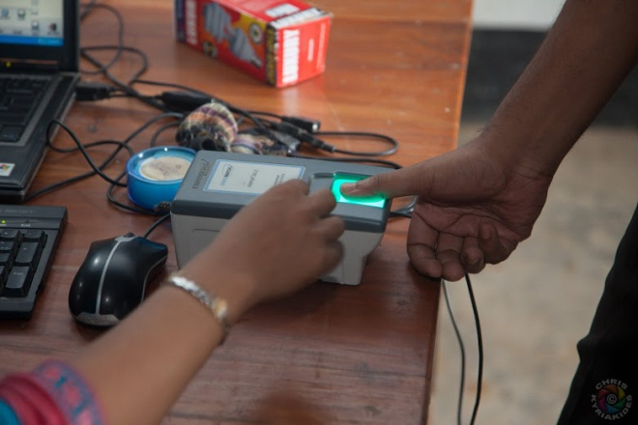
Scope of interventions
The electoral law requires that the voter list is updated in January of every year and also allows for continuous voter registration. In this light, SEMB supported the nation-wide update of the voter list to ensure that a credible voter roll can be maintained. This was done ahead of the next parliamentary election and to further promote and consolidation the results of the PERP project, which successfully delivered one of the most complete and accurate voter list in the country’s history. At same time, SEMB initiatives promoted the decentralization of the voter registration system, in line with BEC Strategic Plans and provided technical know- how to enhance the continuous voter registration system.

Planned Activities and Results

Pilot of Voter List Update Programme

Four voter registration pilots were carried out in July-August 2011 which added 9802 new voters to the list.
This served as a successful basis for the planning and roll-out of the 2012 nation-wide voter registration update programme intended to bring the voter roll up to date. The pilots successfully identified expected increase of voters; estimated numbers of new voters; likely voter registration challenges and responses; number of staff required for update and types of training required among other areas. The pilot resulted in an enhanced standard operating procedures (SOPs) for voter registration that built on the SOP used for the 2008 election. The revised SOP was subsequently used for 2012 update.

A series of workshops and meetings were held prior to the actual piloting to prepare registration forms and other related documents. Evaluation workshops were held after the piloting to assess the methodology and processes leading to the finalization of a uniform methodology before the country-wide update in 2012. SEMB provided technical advice and financial assistance in coordination with PERP – Government of Bangladesh project for the implementation of pilot.

Review of Voter Registration System and Process
Technical assistance to review the Bangladesh voter registration system (BVRS), status of implementation, functionality and sustainability of the software and hardware of existing system was carried out by an international advisor in April to March 2012. Confirmation of the robustness of the voter registration system and processes was reconfirmed and recommendations were provided to further update/improve and maintain sustainability of the existing system.

National Update – Voter List in 2012
The BEC launched the nation-wide voter list update on 10 March 2012. The data collection drive is scheduled to run until mid-December 2012. At start of January 2013 the draft voter roll will be published for public scrutiny leading to its finalisation by 31 January 2013. While the formal data collection drive of BEC was closed in December 2012, the continuous registration of eligible voters after this date will continue.

Since the creation of the fresh and accurate voter list for the 2008 election, the BEC has undertaken only one voter registration update drive in 2009. Continuous registration of voters at the central office was maintained and the decentralization of the registration function to the upazilla level also started. The 2012 national update therefore seeks to capture the information of eligible voters for a three year period to cover all potential voters from the last 2009 drive, ahead of next parliamentary polls. The total voters registered at end of 2009 update stood at approximately 84 million. At end of 2012, numbers on voter roll increased to 92.1 million among which 4,62,01,871 are male and 4,59,27,981 are female.

To support the voter registration process, a Memorandums of Understanding (MOU) between SEMB and the two responsible wings of the BEC namely National Identification and Registration (NID) Wing (previously implemented through PERP - GOB project prior to its close in June 2012) and Election Training Institute (ETI) was signed on 14 March 2012. The total amount of the MOU with the NID wing was for BDT 41,46,16,400 and with ETI BDT 4,10,08,518, which is approximately $6 million United States dollars.

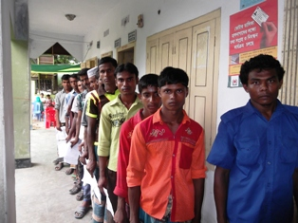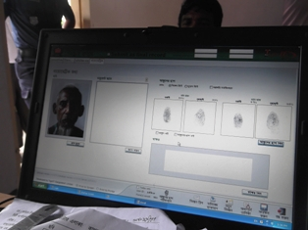
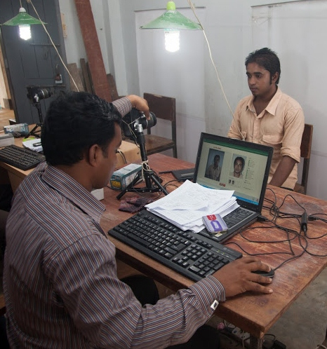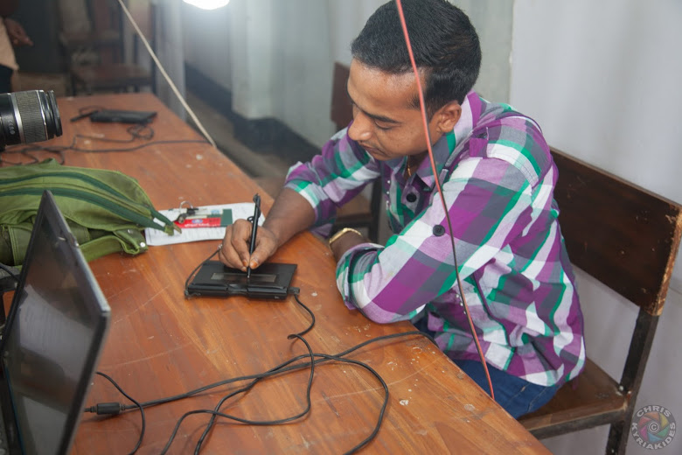
Clockwise – Lines at the Opening of a Voter Registration Centre; Voter Registration Software; Registration of an eligible voter; and Man signs on signature pad during his registration

Procurement of Voter Registration and Support for VR Implementation

Sl | Equipment | Qty
1 | Fingerprint Scanner | 50
2 | Signature Pad | 50
3 | VR Software | 666
4 | Antivirus | 1300
5 | UPS | 600
6 | Electric Plug | 900
7 | USB Hub | 750
8 | Mouse | 1350
9 | Portable Hard Drive | 200
10 | Silicon Membrane | 340
11 | Digital Camera | 50
12 | Light Stand | 1200
The SEMB project supported the procurement of equipment and software to ensure the continued smooth functioning of voter registration activities in the field. Equipment worth approximately $352,700 was procured and customized TIGER IT software for additional voter registration kits was purchased for
$ 270,000. The list of items purchased to support process include:- portable Hard Drive, USB Hubs, power strips, mouse, finger print scanner, signature pad, silicone membrane (for finger print scanners), UPS, light stand, camera and tripod. These procured items represented additional requirements to those equipment and software previously purchased under the donor funded PERP project.

List of Equipment Purchased for Voter Registration

Training for Voter Registration - delivered by ETI
Massive numbers of trainings for voter registration, delivered by ETI, was supported by SEMB. Over 3000. trainings were implemented over the reporting period. Four main categories of training have been implemented.

Training of trainers (ToT) – A total of 520 persons participated in this category and tended to include Deputy Secretaries, Assistant Secretaries, Regional Election Officers, Additional Regional Election Officers, District and Upazila Election Officers. Participants would in turn carry out their own trainings at local level. Content of training focused on:- Rules and Regulations of VR, VR updating process, administrative forms utilised; demonstration of registers and possible risks and responses in the VR process.

Training for Data Entry Operators – A total of 1400 Data Entry Operators, Data Helpers and Proof Readers were trained in 90 batches. The content of training included introduction of VR client software, operating procedures, roles and responsibility of data entry operators and reporting and monitoring.

Training for Enumerators:- a total of 63,918 persons were trained. The content was same as ToT and recipients of the ToT provided these trainings:

Training for Supervisors: – total of 13,693 persons were trained. The content was similar to the ToT and recipients of the ToT provided these trainings. Contents included Rules and Regulations of VR, VR updating process, administrative forms and demonstration of registers, possible risks and responses of VR and supervision procedures.

Voter Education/Information – Voter Registration
A voter information campaign related to voter registration was supported by SEMB, through the PERP project and subsequently through NID wing of BEC, that included the development of a communication plan for voter registration to ensure that voters are fully aware of all activities related to the VR update, including the date, time, and place of registration; information necessary to establish eligibility as well as communication of information to encourage voters' enrol in order to fully participate in elections and country’s decision making, to encourage a fully inclusive roll. A range of measures were utilised spanning print and electronic media, printing of posters, miking in communities, communication through mobile technology – sms, among others.

Examples of Items Produced for Voter Information

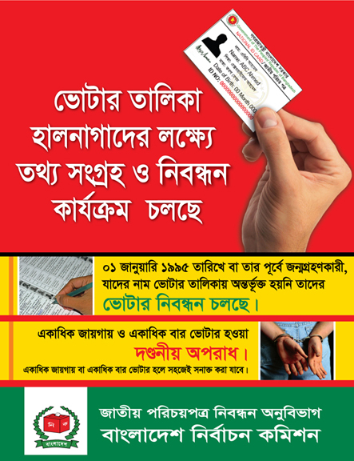
Left - Poster explaining the eligibility criteria for Voter Registration – and stating that registering twice is illegal. Poster distributed in communities and placed on walls at voter registration centres
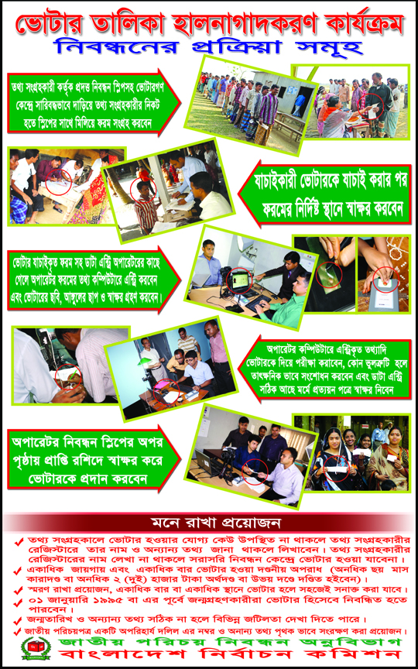
Left - Poster explaining the steps for Voter Registration – placed in communities and at voter registration centres

Below – pamphlet explaining the voter registration process which is widely distributed in communities.

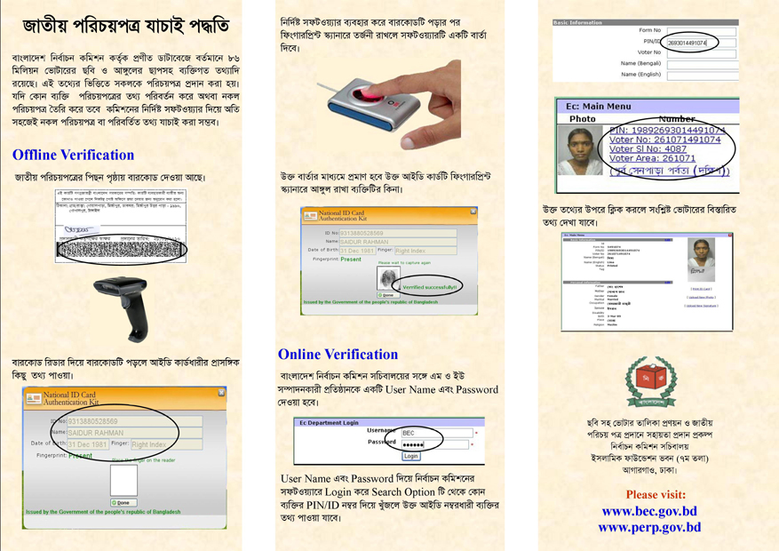
BEC/SEMB Monitoring of VR Process
SEMB supported the organisation of lessons learned workshops after select phases of voter registration update and carried out regular monitoring of the process, through the formation of monitoring team comprised of SEMB and BEC personnel.

The main lessons and findings emanating from these two monitoring and review processes have suggested that the voter registration process is proceeding as planned and is on schedule to complete data collection by mid- December 2012. Significant capacity and knowledge from technical assistance provided previously for the last parliamentary election and prior still exists and has been sustained. In particular, the Voter Registration process appears to have maintained its high standard and feedback from a range of interlocutors suggests that there is continued confidence in the quality of the voter registration process. The process has however not been without challenges which include need for greater and more effective training of election workers and increased voter awareness to ensure voters are fully knowledgeable of expected processes; difficulties with accessing remote areas plus continued need for vigilance and pro-active responses from BEC to ensure that the VR process remains impartial and completely separate from all political influence.

Decentralisation of Voter Registration
Decentralization of the voter registration system continues to be a priority for the BEC and the implementation of the local voter registration system (LVRS) is expected to be a gradual process rolled out and consolidated over the coming years. In March 2012, SEMB provided technical assistance to assist the BEC to plan for the piloting of the decentralization of VR to the field level – upazilla, district and regional level. Recommendations on the design, installation, operation and the corresponding procedures as well as required software upgrades (proposed) to bring the LVRS decentralization into operation were prepared. The BEC has decided to delay the pilot till 2013.

Establishment of Coordination Committee
A coordination committee was formed during the first quarter of 2012 to serve as a forum to ensure maximum coordination of all activities related to the voter registration and its decentralisation. The committee is chaired by the Additional Secretary of the BEC and SEMB NPD and includes representatives from the relevant projects of Construction of Server Stations for Electoral Database (CSSED), Preparation of Electoral Roll with Photographs (PERP) (changed to NID Director following close of PERP) and World Bank’s IDEA project as well as SEMB.

3.6 Preparation for next parliamentary election 2013/4

Scope of interventions
Initiatives in this area aimed to support the preparation for the next parliamentary election. The election can take place anytime within a 90 day period spanning October 2012 to January 2013.

Election Planning Mission
An Election Planning Mission was fielded on 25 August to 4 September 2012 which assessed the on-going technical preparations for the upcoming parliamentary election in 2013/4 and provided recommendations to the Election Commission to enhance the quality of their planning. Discussions and recommendations of the mission focused on producing a more detailed strategic and operational plan/calendar for elections to enhance BECs existing framework plan. Timely identification of all planning and procurement needs was promoted as well as greater stakeholder outreach. Recommendations for reviewing the election recruitment methodology and training was also produced to ensure that election staff are identified and trained early and selection duly considers the current political environment. The mission provided vital inputs to guide the development of these processes and subsequently the electoral assistance strategy of SEMB in 2013, to this end.

Synergies of SEMB Outputs and Contributions to Preparation for Next Parliament Election
A range of initiatives in the other five (5) output areas of SEMB contributed directly to enhancing the capacity of BEC to prepare for the next parliamentary election.

SEMB supported a series of trainings for election officials to boost the capacity for training ahead of the parliamentary election. BRIDGE Training workshops enhanced the organisation’s training techniques and methodologies by exposure to more modern approaches for key trainers. The training department’s ability to develop and customise training modules was strengthened and workshops on strategic planning as well as the development of a draft training plan increased the institutional capacity for more systematic, well planned and implemented training programmes. Specialised trainings have provided a basis for election officials to collectively review key electoral processes. For example, training on electoral legislation facilitated a collective review of electoral law – RPO, and for comparisons to be made with electoral laws of other countries to inform the on-going review of legislation. While trainings on election administration reviewed strengths and gaps in existing processes to support review of rules and procedures.

This was further complimented by post-election workshops that gleaned vital lessons to provide inputs to review electoral frameworks and procedures and to feed into the finalisation of step by step guides and manuals such as Returning Officers guide and Presiding Officers guide. On-going support for voter registration lays the groundwork for finalising a credible voter list which rests at the heart of successful elections. Over 3000 planned trainings have ensured that voter registration workers, such as data entry collectors and enumerators are aware and knowledgeable of their roles.

Work in Communication ensured that BEC can engage with stakeholders such as civil society and provided avenues for the commission to receive relevant stakeholder feedback to reflect in their decision making in processes such as delimitation, voter registration and voter education. SEMB assistance in ICT to develop an electronic election management system for more effective results management and candidate management serve to ensure greater efficiency and transparency for the parliamentary election and beyond.

3.7 INDICATOR FRAMEWORK

Output | Indicators | Target | Progress achieved
Output 1: Professionalised and strengthened training by the BEC | Written vision statement, procedures and work plan of ETI;  Improvements in skills levels of BEC permanent staff;  Number of BRIDGE courses held and number of participants attended;  Number of specialised courses held for permanent BEC staff;  Number of trainers available at training institute; | ETI Strategic Plan and Action Plan developed and approved;  Revision of BEC structure and job description of permanent staff;  4 English Language training courses with the British Council complete for 72 staff members;  Introduction of BRIDGE methodology to improve the capacity of BEC staff;  Number of permanent staff trained following BRIDGE methodology;  4 election commission officials fully accredited as BRIDGE facilitators; | ETI Strategic Plan drafted and submitted to the commission for approval;  BEC organogram and job description revised in line with BEC long term Strategic Plan and Action Plan to ensure better service delivery;  54 BEC staff received training in 3 English Language training course implemented by British Council;  BRIDGE methodology introduced and 24 different BRIDGE module training planned; 6 training have been completed (detail mentioned in the narrative report)  4 fully accredited BRIDGE facilitators with an additional 18 undertaking required field hours to become accredited.
Output2: Strengthen BEC capacity to efficiently manage decentralisation and institutional growth | Consultations undertaken on BEC strategic plan;  BEC strategic plan in place and publicly available;  Post-election workshops held and lessons documented; | 7 dissemination workshops held in 7 election regions;  BEC strategic plan and Action Plan published and disseminated;  7 post-election lessons learnt workshops held in 7 election regions. | 5 dissemination/ consultation workshops held at the field level with 266 officials in attendance;  BEC strategic plan and Action Plan published and distributed among all national and local offices and different stakeholders;  5 post- election lessons learnt workshops held with 266 of officials in attendance
Output 4: Professionalised and strengthened ICT Wing of the BEC | Wing and branch managers are counter parted on recruitment; | BEC recruited professional ICT officers for ICT wing; | BEC recruited 17 professional personnel for ICT wing including 1 System Manager, 2 System Analyst, 1 Senior Maintenance Engineer, 1 Maintenance Engineer and 4 Programmer for ETI and NID wing.
Output 5: Enhanced capacities to prepare and disseminate credible and accurate photo voter list | Updated processes reflecting decentralized service delivery;  Approved rollout of BVRS implementation plan including provision for pilots;  Accuracy of voter list;  Comprehensive voter education and awareness plan for decentralized VR process developed and conducted;  BEC staff with VR responsibilities are trained;  Approved SOPs distributed to relevant BEC officials;  Number of new registered voters; | VRS implementation plan developed and decentralised;  Updates completed to voter list in four areas piloted;  A voter education programme developed on the updated voter registration process with TVCs, pamphlets, posters, miking, SMS service etc;  Number of officials trained with other voter registration officials (enumerators, supervisors etc) on the voter registration update program.  SOPs finalised and implemented for voter register update programme in 2012;  Number of new voters; | Implementation Plan for decentralisation of voter registration prepared. BEC has decided to pilot decentralisation in first half of 2013.  Voter list update programme piloted in Patnitala, Naogaon; Kaliganj, Gazipur; 18 no Ward, Dhaka and Zhilonga, Cox’sBazar.  A voter education programme was developed by the BEC through the PERP project with technical assistance from SEMB on the updated voter registration process with TVCs, pamphlets, posters, miking, SMS services etc  60498 trained on the voter registration update program. (49,361 enumerators and data entry operators, 10,625 supervisors and 512 upazila officers)  Awareness on decentralised process will be done in 2013 with launch of pilot.  SOPs finalised for the 2012 voter register update programme with the revised SOPs implemented;  7.01 million new voters registered as of January 2013.
Output 6: Support to activities in the run up to the parliamentary elections in 2014 | Number of papers produced on electoral issues;  Number of stakeholder consultation held; | A step by step guide produced and published for electoral officers;  Stakeholder meetings with CSO, political parties, media and other stakeholders; | 5000 copies of Step by Step Guide printed and disseminated amongst presiding officers. Step by Step Guide for returning officers in the drafting phase;  New Commission held several consultations with different stakeholders including one with CSO held on 13 September 2012, one with media on 10 October, one with NGOs on 22 November 2012 and 28 with different registered political parties from 26 November 2012 to 6 December 2912. Main opposition BNP did not join the BEC consultation.
Chapter 4: SEMB MANANGEMENT and OPERATIONS
Management structure
SEMB is a Nationally Executed Project (NEX) and the Government of Bangladesh, through the Economic Relations Division (ERD) of the Ministry of Finance, and the Bangladesh Election Commission, is responsible to ensure direct and transparent administration and management of project funds. Bangladesh Election Commission is the implementing agency, responsible for management and implementation of project, ensuring UNDP policies and procedures are adhered to under guidance of through the National Project Director (NPD) and the Project Steering Committee. SEMB project is therefore embedded within the Commission to promote ownership, accountability, national capacity development and sustainability of efforts. UNDP is responsible for project quality assurance and is responsible for development partner coordination, joint administration of the resources allocated by development partners and mobilization of additional resources.

Programme and Project Management includes the following structures:
Project Steering Committee

NPD (Member Secretary)
Programme Assurance
UNDP Programme

Project Management and Support Unit

Project Management Structure
Chair: Secretary, ECS
Relevant Government Ministries
Technical Experts (International)

Technical Experts (National)
UNDP/Donor Representatives
Project Implementation Committee
Chair: NPD

Staffing
The SEMB project is currently supported by 21 staff members. The recruitment of the remaining team is at various stages. Please see full status of staff recruitment in Annex.

Monitoring and Evaluation

SEMB project produced quarterly progress and financial reports over the entire reporting period. The Project Implementation Committee (PIC) met regularly to review project implementation and management and there have been six PIC meetings till December 2012. Steering Committee meetings have been less frequent with the first PSC meeting held on 9 October 2012. SEMB was audited by the GoB Foreign Aided Projects Audit Directorate (FAPAD) and no major issues or financial discrepancies were found. The project has also maintained issues and risk logs, which have been regularly updated and duly consider the external environment effect on project implementation.

Indicator Framework
A consultant was contacted to comprehensively review the indicator framework and results chain to ensure that the project can be more effectively monitored and evaluated. A draft indicator framework with outcome and output indicators, modes of verification and relationship of results chain have been developed and will be finalised.

Operational Challenges and Changes to Project

The project experienced a number of changes and challenges over the reporting period which are detailed below:-

Changes to Election Commission

- Organisational Restructuring - In July – October 2011, BEC underwent a process of internal organisational restructuring (also supported by project). Project implementation and work with wings, in some instances, had to be put hold to allow for finalisation of restructuring process and confirmation of departmental mandates.

To finalize the job description for different level officers, a workshop was organized in HRDC, Koitta, Manikgonj from 23-25 September 2011. Previous CEC Dr. ATM Shamsul Huda, Election commissioner Mr. Sohul Hossain, Mr. Sakhawat Hussain, Dr. Muhammed Sadique, secretary of Bangladesh Election Commission, Mr. Md. Sirazul Islam, Additional secretary of BEC and relevant different level officers of BEC were present in the workshop. Through different group work officials finalized their job description which helped substantiate their role and responsibilities in performing their job.

- Change in Project Leadership

National Project Director (NPD)- Md. Sirazul Islam, Additional Secretary, Election Commission Secretariat (ECS) was selected as the full time NPD of the SEMB project on 7 March 2012. He continues his responsibilities as Additional Secretary of the ECS, in addition to providing overall technical, financial and administrative oversight for the project. Prior to the selection, the project had an interim NPD, at the level of Deputy Secretary, pending the identification of a more suitably ranked official.

Project Coordinator - The Project Coordinator resigned from his post on 1 March 2012, effective 1 April 2012. In the interim, the Training Expert, SEMB project serves as the acting PC. Recruitment of PC is in final stages.

Commissioners - New Commissioners were selected in February 2012. Given the nature of SEMB several activities required Commission buy-in and approval prior to implementation. Time for transition and start up period for Commissioners was required.

- Change in project premises - During the first week of February 2012, the project office shifted from the BEC to occupy new premises located on the 9th floor of the Islamic Foundation Building, Sher-E-Bangla-Nagar, Agargaon, Dhaka.

Partnerships
Close partnerships and synergies were maintained with the range of projects implemented by the Election Commission, namely PERP-GoB, CSSED and IDEA. In order to provide coordinated support for voter registration, assistance was provided through the PERP-GoB project. Plans for the decentralisation of voter registration and broader electoral services leading to the full functioning of the constructed local election offices was carried out in partnership with the CSSED and IDEA projects. A Coordination Committee to ensure ample synergies and coordination among these projects was established, with SEMB’s leadership.
The project also sought to promote greater partnerships with civil society organisations. In this regard, Shujan, a civil society group, worked with the BEC for the organisation of candidate debates and dissemination of information for local and city corporation elections.

Visibility
The project has ensured the visibility of the project’s donors in its organised events, such as trainings and workshops. Banners and posters have carried the logos of the EU, UKAID and USAID and UNDP. Messages delivered at all events by the Project Staff, BEC staff and UNDP have focused on the partnership among development partners and the UNDP in support of SEMB.

Pictures of Workshop and Training Banners to underline Partnership Support for SEMB

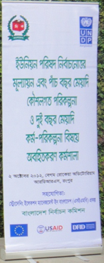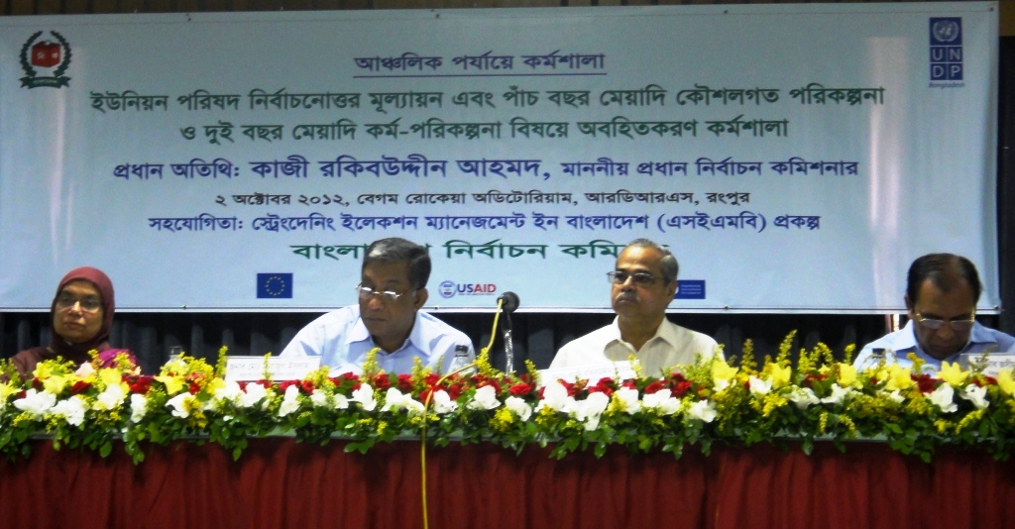
UP Election Lessons Learned and Strategic Plan Stakeholder Consultations
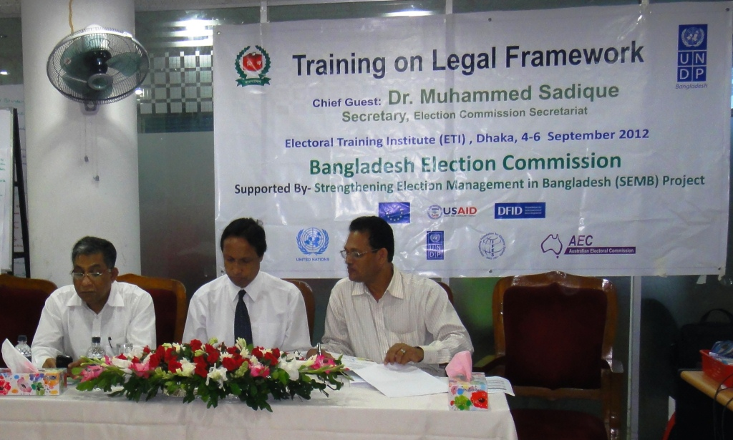
BRIDGE training on Legal Framework with Secretary; Additional Secretary/NPD and Director of ETI.

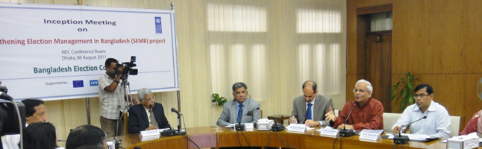
Project Inception Meeting

Chapter 5: LESSONS LEARNED AND WAY FORWARD

Supporting sustainability of past support
Succeeding project can be designed to promote the sustainability of past assistance. The SEMB project has been designed in this way and includes a component on voter registration to ensure the sustainability of the support provided through the PERP project. This has proved to be successful and the design also allows for donor support to be systematically phased out as local capacity increases.

Electoral assistance is more effective if provided throughout the electoral cycle
Electoral assistance that adopts a more long term approach to capacity development that runs the entire electoral cycle, i.e. beyond the general election event, is more effective at building capacity and achieving sustainable results.

Use of pilots and research leads to more informed decision making by the Commission
Use of pilots is an efficient way to ascertain the feasibility or effectiveness of an initiative and to address concerns prior to implementation or country wide roll out/scaling up. This was done for voter registration and to guide decision on technological innovations such as electronic voting and the electronic monitoring of polling stations.

Establishment of realistic timeframes for project initiation stages
Requisite timeframes for start-up activities and resources should be duly factored into the implementation stages and expectations of project results.

Technical and political dimension of Elections
Elections are both technical and political processes and therefore the provision of technical assistance should also consider, and as appropriate, address political culture and other contextual issues that adversely affect the integrity of the electoral process.

Way Forward
The next parliamentary election in 2013 presents the opportunity for the BEC to consolidate the achievements it has made in election administration and to demonstrate its ability to deliver quality national elections, thereby ensuring that the standards set in the 2008 polls can be maintained or surpassed. The project will therefore be positioned to strategically support the plans for the next parliament election as well as to assist greater capacity development within the BEC by further enhancing its institutional and professional capacities.

Professionalised Training- Huge numbers of trainings are envisioned in 2013. SEMB will continue to support ETI’s capacity to plan and implement trainings and will assist the delivery of training programmes and skills development for BEC staff, temporary employees and other electoral stakeholders in a range of election related areas ahead of the election. Trainings will also promote greater interaction and engagement among electoral stakeholders. Assistance will be given to ensure the production of high quality training materials and the establishment of a system for training implementation, evaluation and monitoring. Training to further develop skills related to planning and monitoring will also be undertaken. The BRIDGE methodology will continue to be used and accreditation of a national pool of certified BRIDGE facilitators will be enhanced.

Institutional Development – The project will support the enhancement of BEC internal administration. A review of the status of implementation of BEC Strategic Plan (2011-2016) and Action Plan (2011-2013) will be undertaken and assistance will be provided to update the Action plan and systemise its monitoring.

Communications – Priority will be placed on developing strengthened communications and stakeholder outreach. The project will support the reform of the Communications Unit and development of BEC media and outreach policies and approaches. This will support the BEC’s capacity to plan and implement a communications and stakeholder engagement strategy and more effective voter education and awareness.

Strengthened ICT- Assistance will be provided to enhance the ability of the BEC to utilise ICT in election management raising its transparency and accountability. The finalisation of election software and systems for results management; candidate and political party management and voter interaction systems will be supported. Pilots and trainings on these systems will take place. Capacity Development activities for the ICT wing will also be undertaken.

Maintenance of an accurate voter role – SEMB will provide assistance leading to the finalisation of the voter list and will support/facilitate an independent assessment on the accuracy of the roll. Identification of lessons learnt and best practices will also continue. Technical assistance for implementing the system of continuous voter registration will take place through the piloting of the decentralised voter registration system to the Upazilla server stations to further promote the sustainability of voter registration.

Support to activities in run-up to elections –In addition to the institutional support provided in the above five areas, SEMB will support the development of relevant election manuals, organisation of candidate debates, media monitoring by civil society and monitoring of compliance to regulations and laws.

Chapter 6: FINANCIAL REPORT

BUDGET AND DELIVERY BY MAJOR HEADS

Annex

List of Major Trainings

SL | Training | Participants/Beneficiaries | Duration | Participants |  |  | Outcomes
 |  |  |  | Total | Male | Female
 | BRIDGE Showcase workshop | Officials from election commission secretariat, ETI, NID wing and field offices | 1 day, (29 February 2012) | 30 | 25 | 5 | 20 participants were chosen from 30 participants for TtF training
 | BRIDGE TfF Training (1st batch) | Officials from election commission secretariat, ETI, NID wing and field offices | 10 day (4-15 March 2012) | 20 | 17 | 3 | Officials were exposed to modern and effective training methodologies and approaches and upon completion became semi-accredited BRIDGE facilitators
 | BRIDGE TfF Training (2nd batch) | Officials from election commission secretariat, ETI, NID wing and field offices | 10 day (18-28 September 2012) | 20 | 19 | 1 | Officials were exposed to modern and effective training methodologies and approaches and upon completion became semi-accredited BRIDGE facilitators
 | Training on “Introduction to Electoral Administration” (1st batch) | Officials from election commission secretariat, ETI, NID wing and field offices | 3 day (15-17 May 2012) | 20 | 16 | 4 | Officials learnt relevant election administrative issues and how to better manage elections
 | Training on “Introduction to Electoral Administration” (2nd batch) | Officials from election commission secretariat, ETI, NID wing and field offices | 3 day (28-30 June 2012) | 20 | 16 | 4 | Officials learnt relevant election administrative issues and how to better manage elections
 | Training on “Legal Framework and Elections” | Officials from election commission secretariat, ETI, NID wing and field offices | 3 day (4-6 September 2012) | 20 | 18 | 2 | Participants learnt about different legal aspect regarding election; reviewed RPO – BD electoral law and made comparison with other countries
 | Training on gender and elections | Officials from election commission secretariat, ETI, NID wing and field offices | 3 days  (15-17 October 2012) | 20 | 10 | 10 | Participants learnt about gender in elections and framework for BEC gender strategy produced
 | Training on Training and Capacity Building Strategy | Officials from election commission secretariat, ETI, NID wing and field offices | 3 day (21-23 October 2012) | 20 | 19 | 1 | ETI and BEC sensitized about gap in professional skills and strategy to overcome
 | Formulation workshop of Electoral Training Institute (ETI) Strategic Plan | Officials from election commission secretariat, ETI, NID wing and field offices | 3 day (3-5 June 2012) | 20 | 18 | 2 | A draft strategic plan developed for ETI with 5 strategic goals.

Key Workshop and Meetings Held

SL | Workshop | Participants/Beneficiaries | Duration | Participants |  |  | Outcomes
 |  |  |  | Total | Male | Female
 | Dissemination workshop held on ‘Five years Strategic Plan and Two years Action Plan in Sylhet, Rajshahi, Rangpur, Khulna and Barisal electoral region | Election officials of district and upazilla level | Each one is for ½ day  24 May 2012 (Sylhet),  13 June 2012 (Rajshahi)02 October 2012 (Rangpur), 23 December 2012 (Khulna) and 31 December 2012 Barisal | 266  33 Sylhet,  78 Rajshahi,  59 Rangpur,  60 Khulna, 36 Barisal | 232 | 34 | Election officials were informed about ‘Five years Strategic Plan and Two years Action Plan’
 | Post Union Parishad election lessons learned workshop held in Sylhet, Rajshahi, Rangpur, Khulna and Barisal electoral region | Election officials of district and upazilla level, officials of district administration and police administration and media | Each one is for ½ day  24 May 2012 (Sylhet),  13 June 2012 (Rajshahi)02 October 2012 (Rangpur), 23 December 2012 (Khulna) and 31 December 2012 Barisal | 420  60 Sylhet  109 Rajshahi  90 Rangpur, 99 Khulna, 62 Barisal | 382 | 38 | Participants of the workshop pointed out important findings and came up with recommendations which will specifically provide guideline and direction to arrange upcoming local and national level elections.
 | Workshop on web-camera installation in Comilla City Corporation Election | Technical experts | 03 January 2012 | 130 | 129 | 1 | Technical Experts were briefed on roles and responsibility of installation and management of WebCam and laptop.
 | Public Meetings to Enhance Voter Awareness | A number of projection meetings were organized with mayoral and councilor candidates  for Comilla City Corporation Elections and Narsingdi by-elections in order to  generate greater awareness among voters on the manifesto, commitments and activities  of the candidates. These meetings were organized by SHUJAN, a civil society group, which was selected to design and organize the campaign activities at the community level. |  |  |  |  | Voters were able to make more informed choices.  A variety of IEC/ BCC materials such as leaflets, posters and comparative statements on the candidates were  printed and distributed to voters during the campaign period.
 | Installation of web-camera in Comilla City Corporation Election for security management | Mass people and voters of that city corporation | 05 January 2012 | 130 technical experts (TEs) installed and maintained  the system. |  |  | Election was free, fair, credible and transparent.  Webcams were installed in 421 polling booths of 65  polling centres. 907 laptops, 972 webcams, 150 power strips and other logistics were used.
 | Voter Awareness in Narsingdi prior to Mayoral election | Multi-media projectors and actual EVMs were used in demonstration sessions during the voter awareness campaigns.  Voters and mass people | 31 Presiding officers,  198 Assistant  Presiding Officers, 62 polling officers |  |  |  | Voters became aware on the use of electronic voting  machines (EVMs).  1000 leaflets on the guidelines for using EVMs  were printed and disseminated to voters during the campaign.  400 training  manuals printed describing the various steps required for using EVMs.  600  manuals were printed for polling officers which outlined their roles and responsibilities.
 | Workshop on web-camera installation in Gazipur-4 Vacant Seat (Parliament) Election 2012 | Technical experts | 28 September 2012 | 98 | 98 | -- | Technical Experts were briefed on roles and responsibility of installation and management of WebCam and laptop.
 | Gazipur-4 Vacant Seat (Parliament) Election 2012: Vigilance of Polling Centres using ICT | Mass people and voters of that constituency | 30 September 2012 |  |  |  | Election was free, fair, credible and transparent.
 | Dialogue with Civil Society on Delimitation of Constituency and Updating of voter Roll | Civil society members and election officials | 13 September 2012 | 150 | 120 | 30 | BEC guided with recommendations about Delimitation of Constituency and Updating of voter Roll
 | Workshop on Demonstration of Election Management System | CEC, Commissioners, Secretary, Additional secretary, Joint secretaries, ICT team of BEC and SEMB | 13 August 2012 at BEC conference room | 21 | 19 | 2 | Some modules such as election schedule management, polling centres management, polling officers management candidates’ asset disclosure processing system and result processing system were developed.
 | Workshop on “Experience and Lessons Learned Sharing: 1st Phase Voter Registration Updating” in Rajshahi region | Enumerator, Supervisor, Data-Entry Operator, Proof Reader, Technical Expert, Team Leader, Upazilla Nirbahi Officers of different upazilla of Rajshahi region/Division. Along with that district and upazilla Election officer of Sirajganj, Pabna, Bogra, Natore, Chapainawabganj, Joypurhat, Naogaon and Rajshahi | 14 June 2012 at Moon Light Garden Convention Center, Saheb Bazar, Rajshahi | 89 | 78 | 11 | To share the experiences of different level officials engaged with voter list updating process and to replicate the best practices in other region of the country
 | “Experience Sharing and Sensitization Workshop on 1st Phase Voter Registration Update” in Cox’s Bazar | Upazilla Election Officers of Cox’s Bazar, members of Special Committees of seven special areas/Upazilas (Cox’s Bazar Sadar, Moheshkhali, Pekua, Chokoria, Technaf, Ukhia and Ramu) of Cox’s Bazar and members of District Coordination committee | 24 June 2012 at Ocean Paradise Hotel, Cox’s Bazar | 127 | 124 | 3 | The participants were sensitized on the importance of preparation of an accurate voter list  The participants made specific commitment to take special measures so the non-eligible and non-Bangladeshi could not be included in the voter list
Consultation Schedule of Election Commission with different stakeholders
Date of Consultation | Time Schedule | Name of Stakeholder
13 September 2012 | 11.00AM | Civil Society Organizations
10 October 2012 | 11.00AM | Media (Print & Electronic)
22 November 2012 | 11.00AM | NGO

Date of Consultation | Time Schedule | Name of Political Party
26 November 2012 | 10.00AM | - Islamic Front Bangladesh
 | 11 .00AM | - Islami Andolon Bangladesh
 | 12.00 PM | - Islami Oikkojot
 | 2.00 PM | - Oikkobaddho Nagorik Andolon
 | 3.00 PM | - Krishok Shramic Janata League
 | 4.00PM | - Bangladesh er Samajtantric Dal (BaSaD)
27 November 2012 | 10.00AM | - Ganotantri Party
 | 11 .00AM | - Ganofront
 | 12.00 PM | - Ganoforum
 | 2.00 PM | - Khelafat Majlish
 | 3.00 PM | - Jamiote Ulamae Islam Bangladesh
 | 4.00PM | - Jaker Party
28 November 2012 | 10.00AM | - Jatio Ganotantric Party
 | 11 .00AM | - Jatio Party
 | 12.00 PM | - Jatio Party – JP
 | 2.00 PM | - Jatio Samajtantric Dal- JaSaD
 | 3.00 PM | - Jatio Samajtantric Dal- JSD
 | 4.00PM | - Bangladesh Worker’s Party
29 November 2012 | 10.00AM | - National Peoples Party
 | 11 .00AM | - Bangladesh Kollan Party
 | 12.00 PM | - Pragatishil Ganotantric Dal
 | 2.00 PM | - Bangladesh er Communist Party
 | 3.00 PM | - Bangladesh Awami league
02 December 2012 | 10.00AM | - Bangladesh Islami Front
 | 11 .00AM | - Bangladesh Khelafot Andolon
 | 12.00 PM | - Bangladesh Khelafot Majlish
 | 2.00 PM | - Bangladesh Jatio Party
 | 3.00 PM | - Bangladesh Jatiotabadi Dal (BNP)
03 December 2012 | 10.00AM | - Bangladesh Jatio Party – BJP
 | 11 .00AM | - Bangladesh Jamaete Islami
 | 12.00 PM | - Bangladesh Tarikot Federation
 | 2.00 PM | - Bangladesh National Awami Party
 | 3.00 PM | - Bangladesh National Awami Party- Bangladesh NAP
04 December 2012 | 10.00AM | - Bangladesh Muslim League
 | 11 .00AM | - Bangladesh er Biplobi Worker’s Party
 | 12.00 PM | - Bangladesh er Sammobadi Dal (M.L.)
 | 2.00 PM | - Bikalpodhara Bangladesh
 | 3.00 PM | - Liberal Democratic Party- L.D.P.
Documents and Publications

Sl | Name of Publication | Time of Publishing
01 | Revised Bangladesh Election Commission Organization Structure | 2011
02 | Step by Step Guideline to conduct Elections – Presiding Officers | 2011
03 | ETI Strategic Plan | 2012
04 | 4 BRIDGE training module on:  1). Introduction to Electoral Administration  2). Legal Frame work and Elections  3.) Gender and Elections  4.) Training and Capacity Building Strategy | 2012
05 | Guide on use of EVM for presiding and assistant presiding officers (in Bangla) | 2012
06 | Reform in Electoral Laws: Dialogue with Political parties | 2012
07 | Statistical Report: 9th Parliamentary Elections | 2012

Project Recruitment Status

Sl No | Designation | Status
01 | International Training and Capacity Building Expert | One temporary person is currently on board. Permanent Expert identified and process being finalised and expert expected to be on board from January 2013
02 | International Communication Expert | Communication Expert identified, process being finalised and expert expected to be on board from January 2013
03 | International ICT Expert | On board
04 | Project Coordinator | Coordinator resigned. Training and Capacity Building Expert currently acting as Coordinator. Candidates interviewed and identified. BEC feedback pending.
05 | Operation Manager | Interview scheduled for first week of November, expected to be on board from January 2013
06 | Project Expert | On board
07 | Finance Expert | On board
08 | Monitoring and Evaluation Expert | On board
09 | Communication Expert | Interview scheduled for first week of November
10 | Training and Capacity Building Expert | Ob board but currently acting as Coordinator
11 | Human Resource Expert | ongoing
12 | Senior System Administrator | On board
13 | VR Datacentre Manager | Not yet recruited
14 | ICT Technical Expert | Not yet recruited
15 | Website Manager | On board
16 | Programmers (2) | On board
17 | Project Associate | Not yet recruited
18 | Project Assistant (3) | On board
19 | Training Assistant (2) | On board
20 | Finance and Admin Assistant | On board
21 | Office Secretary | Interview scheduled for 1st week of November
22 | Drivers (4) | On board
23 | Messenger | Not yet recruited
24 | National Programme Officer | On board
25 | Programme Specialist | On board

BRIDGE – Building Resources in Democracy, Governance and Elections and is a modular professional development programme, with a particular focus on electoral processes.
Preparation of the Electoral Roll with Photographs (PERP) project produced a fresh biometric voter list with over 81 million voters
The Commission was headed by a 3 member Commission until February 2012 when new Commissioners were appointed and the numbers increased to 5.
total number of training is 3333
PERP-GoB closed in June 2012. Its activities were taken over by the NID Wing that covers NID and Voter Registration.

